# ABSTRACT

Nowadays shopping is easy and at the fingertip. But we don't know that e-commerce provides trust full, quality products. Most of the time the providers provide fake and low quality products to the end user as fraud activities. And also it takes a lot of time to get to the end user. so we introduce a mobile app called ' **E-KART** '.

The E-KART is not totally an e-commerce app, it is the combination of offline and online store which customer can choose the product, check the quality, verifying it working or not, after the customer satisfied he can pay Through the app to avoid the waiting time for billing to make a big queue and other delays. As the store management side that helps to minimize the employees by removing the cashier, butcher, reduce the effort of the store manager, improve productivity and sales etc. It can also provide the maximum revenues just through the app by direct customer to store dealing.

We provide extra features like in app payment system, same login page for user and customer, reward for buying product from the app etc.

The application also features a single login page for both users and store managers ensuring a seamless user experience. E-KAR is build using python as the backend-language, with python-kivy and kivyMD as the framework, demonstrating the potential of these technologies in developing robust and user friendly applications. The successful implementation of E-KART signifies a step forward in retail management and customer service, paving the way for future advancement in this field.

# INTRODUCTION

The digital revolution has fundamentally reshaped consumer behaviour, with mobile devices becoming an ubiquitous extension of our daily lives. This shift has significantly impacted the e-commerce landscape, driving a relentless demand for convenient and seamless shopping experiences. Traditional brick-and-mortar stores now face the challenge of bridging the gap between their physical presence and the online world. Customers, accustomed to the ease of online shopping, crave innovative solutions that streamline the in-store experience. E-KART, a mobile application designed for both customers and businesses, addresses these evolving needs by offering a feature-rich platform that revolutionizes the way we shop.

## Inefficiencies in the Traditional Shopping Experience

The current in-store shopping experience often involves a series of inefficiencies that can lead to customer frustration and lost sales opportunities for businesses. Waiting in long checkout lines, manually adding items to a cart, and encountering out-of-stock products are all commonplace issues that detract from the shopping experience. Additionally, businesses struggle to integrate online and offline shopping experiences, requiring them to manage separate systems and inventory across various channels. This siloed approach creates a disconnect between online product information and in-store availability, hindering seamless customer journeys.

## The Power of Agile Development

E-KART was developed using the Agile development methodology, a flexible and iterative approach that prioritizes continuous improvement and user feedback. This framework proved particularly valuable in creating an app that truly meets user needs. Agile development allows for rapid prototyping and testing of features throughout the development process. By gathering user feedback at each stage, the E-KART development team was able to ensure the final product addresses real-world problems and delivers an experience tailored to user expectations.

## E-KART: A Feature-Rich Mobile Shopping App

E-KART empowers customers with a suite of user-friendly functionalities designed to elevate the shopping experience:

* **Scan & Add:** Customers can effortlessly add items to their shopping list by scanning product barcodes or custom QR codes offered by participating businesses. This eliminates the need for manual item selection, minimizing errors and saving valuable time.
* **Built-in Wallet:** E-KART features a secure in-app wallet, allowing users to store and manage funds for hassle-free in-app purchases. This eliminates the need to carry cash or juggle multiple payment methods at checkout, fostering a streamlined and convenient payment process.
* **Item Management:** Customers have complete control over their shopping list. They can create, view, and delete items as needed, ensuring their list accurately reflects their shopping requirements and providing flexibility during their shopping trip.
* **Custom QR Code Generation (Optional):** Businesses can leverage E-KART's optional feature to generate unique QR codes for their products. These QR codes can enhance product information accessibility for customers and potentially offer targeted promotions, fostering deeper customer engagement and brand loyalty. (Note: Consider security implications and suggest exploring industry-standard QR code generation libraries)
* **Offer Management:** Customers can view and potentially redeem promotional offers provided by businesses participating in the E-KART ecosystem. This feature incentivizes customers to shop at participating stores and fosters brand loyalty within the app.

## A Win-Win Solution for Customers and Businesses

E-KART offers a compelling value proposition for both customers and businesses, fostering a symbiotic relationship within the app's ecosystem:

* **Customer Benefits:** Customers experience faster checkout times, reduced shopping list errors, secure in-app payments, access to promotional offers, and an overall streamlined shopping experience.
* **Business Benefits:** Businesses benefit from improved operational efficiency, reduced wait times at checkout, enhanced customer engagement through targeted in-app promotions, and potential cost savings through a unified online and in-store shopping experience.

This introduction has established the context for this project by highlighting the challenges in the current e-commerce landscape, the advantages of the Agile development methodology, and the core functionalities offered by the E-KART mobile app. The following sections will delve deeper into the technical implementation of E-KART, exploring the chosen development framework, backend infrastructure, and security considerations. We will also explore the potential for future development and the app's impact on the evolving e-commerce landscape.

# ASSISTING PACKAGES

## SYSTEM REQUIREMENT

Desktop/Laptop with: -

* 4 GB RAM
* 25 MB storage
* Windows/Linux distributor OS

## PROGRAMMING LANGUAGE

**PYTHON**

* Used for backend process for doing basic process like database connection, simple mathematical operations and other critical and non-critical functions.

## IDE/COMPILER

**VISUAL STUDIO CODE**

* Visual studio code is a software developing IDE provide by Microsoft help to compile, debug, test and deployment of different programing languages.

**IDLE**

* IDLE is a python compiler provided by python help to compile python program, install different packages and debug programs

**PYCHARM**

* Pycharm is also a IDE provided by Jet Brains which provide intelligent code completion, database support, etc.

## HEADER PACKAGES

**PYTHON-KIVY**

* Kivy is an open-source Python framework for developing multi-touch applications.
* Used for framework designing.

**PYTHON-KIVYMD**

* An extension of kivy which provide google based design for various purpose in the app.
* Mostly help to create UI/UX designing.

**RANDOM**

* A python module that help to create a random number from a range of number or a list.
* Help to generate OTP and also help in selecting recommended items on customer screen.

**KIVY_GARDEN**

* It is a package that come with kivy that handle the QR-code creating and reading QR-code data.
* Help to create custom QR-code.
* Helps to scan QR-code.

## PACKAGE BUILDERS

**BUILDOZER**

* A python package that work belongs to P4A (python for android) helps to build apk and also to build IOS files.
* Complete customizable packages that help to create apks.

**PYINSTALLER**

* This is also a package that help to build the app for windows, Linux, Unix system.
* Create highly efficient and compressed files for different platforms.

## BUILD DEVICES

* SAMSUNG J2 2016 – ANDROID 6.0.1 (1.5GB/8GB)
* LENOVO NOTEBOOK COMPUTER – WINDOWS 10 PRO (4GB/1TB)

# Kivy and KivyMD

## Introduction to Kivy

Kivy is an open-source Python framework for developing multi-touch applications. It enables the creation of cross-platform applications that run on various operating systems, including Windows, mac

OS, Linux, iOS, and Android. Kivy is renowned for its simplicity, flexibility, and scalability, making it an ideal choice for developing mobile applications with rich user interfaces.

## Key Features of Kivy:

1. **Cross-Platform Compatibility:** Kivy applications can be deployed across multiple platforms without requiring significant modifications, thanks to its platform-independent nature.

2. **Multitouch Support:** Kivy provides robust support for multitouch interactions, allowing developers to create intuitive and interactive user interfaces optimized for touch-enabled devices.

3. **Pythonic Syntax:** With its Pythonic syntax and object-oriented design, Kivy simplifies the development process, making it accessible to developers with varying levels of expertise.

4. **Customizable Widgets:** Kivy offers a wide range of customizable widgets and layout managers, enabling developers to design visually appealing and responsive user interfaces tailored to their specific requirements.

5. **OpenGL Acceleration:** Kivy leverages the power of OpenGL for hardware-accelerated rendering, ensuring smooth performance and fluid animations even on resource-constrained devices.

## Introduction to KivyMD

KivyMD (Material Design for Kivy) is a collection of Material Design components and widgets designed to complement the Kivy framework. Inspired by Google's Material Design guidelines, KivyMD provides developers with a rich set of UI elements that adhere to modern design principles, enhancing the aesthetic appeal and usability of Kivy applications.

## Key Features of KivyMD:

1. **Material Design Components:** KivyMD offers a comprehensive library of Material Design components, including buttons, cards, dialogs, navigation drawers, and more, allowing developers to create visually cohesive and consistent user interfaces.

2. **Responsive Layouts:** KivyMD facilitates the creation of responsive layouts that adapt seamlessly to different screen sizes and orientations, ensuring optimal user experience across a wide range of devices.

3. **Theming Support:** KivyMD provides support for theming, allowing developers to customize the appearance of their applications to match their branding or aesthetic preferences effortlessly.

4. **Integration with Kivy:** KivyMD seamlessly integrates with the Kivy framework, enabling developers to leverage the full power and flexibility of Kivy while benefitting from the rich set of Material Design components offered by KivyMD.

5. **Community-driven Development:** KivyMD is actively maintained by a vibrant community of developers, ensuring regular updates, bug fixes, and new feature additions to keep pace with evolving design trends and best practices.

# MAIN MODULES IN THE APP

This chapter delves into the core modules and user interfaces (screens) that make up the E-KART mobile application. Here, we'll explore how these components work together to deliver seamless user experiences for both customers and store managers.

## Core Modules: The Building Blocks of E-KART

While not explicitly mentioned here, consider briefly mentioning the essential modules that power E-KART's functionalities. These include UI framework (e.g., KivyMD), Kivy Garden for QR code functionalities, shopping list management, in-app wallet, and backend communication.

## Navigating the App: Exploring Key Screens

This section focuses on the user experience, guiding the reader through the app's key screens from the perspective of both customers and store managers.

**Customer Screens**

* **Scan and Pay:** This screen allows customers to scan product barcodes or QR codes with their camera. Upon successful scanning, the product information should be displayed and potentially added to the customer's shopping list for a streamlined checkout process.
* **Shopping List:** This screen displays the scanned products, allowing customers to view, edit quantities, or remove items as needed. Consider mentioning the option to clear the list entirely.
* **Wallet:** E-KART offers an in-app wallet, dedicate a section to explain how customers can securely add funds, view their balance, and potentially track transaction history. Emphasize the security measures implemented to protect user financial information.
* **Offers and Rewards:** This screen showcases promotions and rewards available at participating stores within the E-KART ecosystem.
* **Notifications:** This functionality keeps customers informed about store updates, promotional offers, and potentially order status updates.
* **Profile:** This screen allows customers to view and potentially edit their personal details within the app.
* **List Items from Nearby Stores:** This feature helps customers browse and discover products available at nearby stores based on user location (consider mentioning potential privacy implications of location access).

**Store Manager Screens**

* **Add Product:** This screen allows store managers to add new items to the database. Here, they can provide product details like name, quantity, expiry date, batch number, price, and location within the store.
* **Create QR Code:** E-KART allows custom QR code generation, managers can generate unique QR codes for products. The importance of using secure QR code generation libraries to avoid potential data corruption or security vulnerabilities.
* **Delete Product:** This screen provides a way for store managers to remove outdated or unavailable products from the database.
* **View Product Details:** This functionality allows store managers to access and update product information in real-time within the app.
* **Add Offer:** Here, store managers can create promotional offers to incentivize customer purchases. They can also offer discounts on specific products already existing in the database.
* **Withdraw Amount:** This feature allows store managers to transfer accumulated funds from customer purchases to a linked bank account (consider mentioning relevant security measures for financial transactions).
* **Profile Screen:** This screen displays store details including store ID, address, and contact information for reference.

# LOGIN/SIGN-UP

## LOGIN

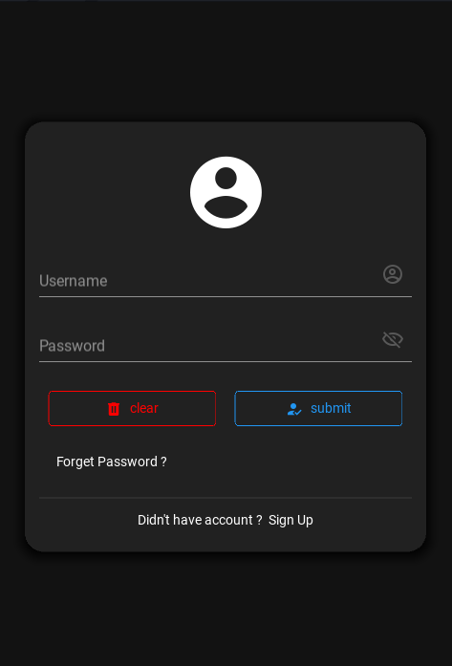**User Credentials:** Users enter their login credentials, typically consisting of a username (or email address) and a password. The app interface should encourage strong password creation practices (e.g., minimum password length, character complexity).

**Role-Based Authorization:** Upon successful authentication, the server grants access to the app based on the user's designated role (customer or store manager). This ensures users only have access to functionalities relevant to their role, safeguarding sensitive information.

**Convenience for Store Managers:** Store managers who also own customer accounts within the E-KART network can effortlessly switch between roles within the app. This allows them to manage their store operations as well as experience the customer journey first-hand.

## SIGN-UP

* **User Name:** name of user for multiple purpose
* **Phone Number:** Phone numbers are crucial for potential account recovery and Multi-Factor Authentication (MFA) if implemented also for login criteria. E-KART utilizes OTP (One-Time Password) verification for phone numbers, ensuring only authorized users gain access with a unique code.
* **Email Address:** A valid email address serves as a primary communication channel for account-related information, password resets, and potential promotional offers.
* **New Password and Confirm Password:** Users create a strong password following best practices (e.g., minimum length, character variety). The "Confirm Password" field ensures typos are caught during registration.
* **Address:** Collecting user addresses can be beneficial for features like location-based store recommendations or streamlined delivery options.
* **Referral Code (Optional):** A referral code field allows users to share their referral codes with friends or family, potentially offering rewards for both parties within the E-KART ecosystem.
* **Terms and Conditions:** A clear and concise presentation of the Terms and Conditions (T&Cs) ensures users understand the platform's policies regarding data privacy, user conduct, and service agreements. Requiring users to acknowledge acceptance of the T&Cs before completing the sign-up process fosters user accountability and transparency.

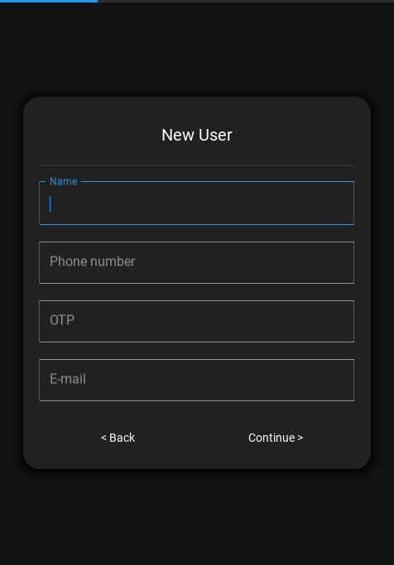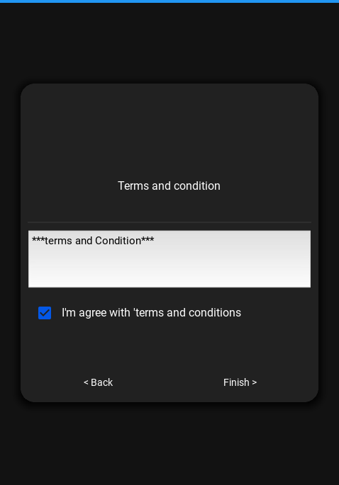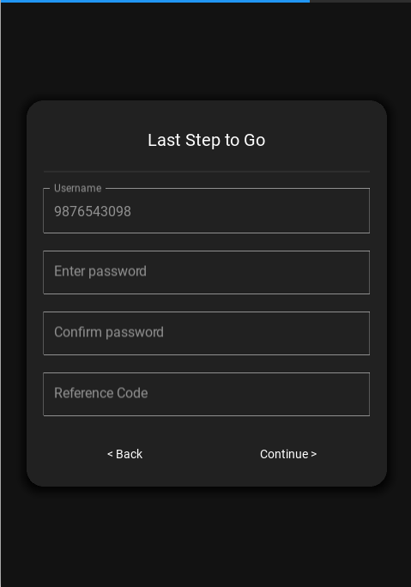

## FORGOT PASSWORD

* **Initiating Password Recovery:** On the login screen, users should find a readily accessible "Forgot Password" option. Clicking on this initiates the password recovery process.
* **Phone Number Verification:** Users enter the phone number associated with their account. E-KART then sends a unique One-Time Password (OTP) via SMS to the registered phone number.
* **OTP Verification:** Users must enter the received OTP within a designated timeframe (e.g., 5 minutes) to verify ownership of the phone number and confirm their recovery request.
* **New Password Creation:** Upon successful OTP verification, users can create a new, strong password for their account. E-KART can enforce best practices for password creation, such as minimum length requirements and character diversity (uppercase letters, lowercase letters, numbers, and symbols).
* **Confirm Password:** Users re-enter the newly created password in a dedicated "Confirm Password" field. This step ensures there are no typos during password creation.

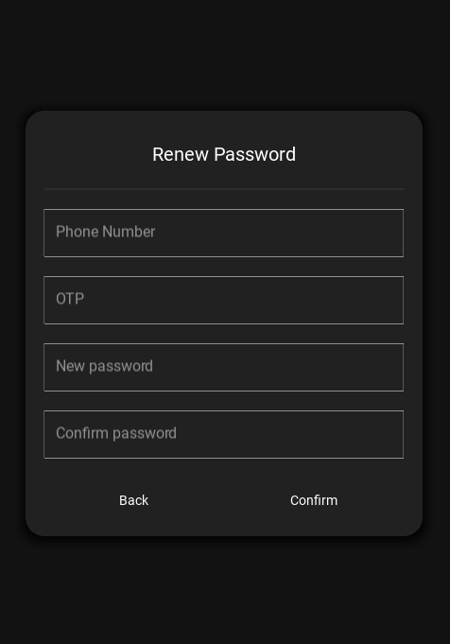

# STORE MANAGER

## HOME SCREEN

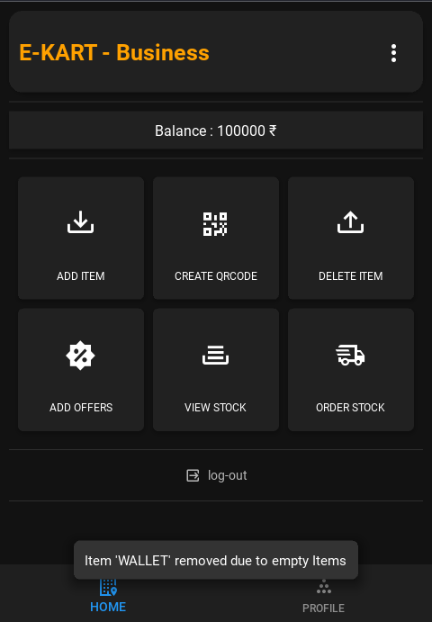

The store manager home screen prioritizes a clear and efficient layout, offering quick access to essential functionalities:

* **Add New Stock**
* **Create QR Code**
* **Delete Stock**
* **Add Offers**
* **View Real-Time Stock**
* **Order Stock Online**

**ADD ITEM**

Building a well-stocked inventory is crucial for store success. E-KART empowers store managers with a user-friendly interface to efficiently add new stock items. This section delves into the functionalities of the "Add New Stock" feature within the store manager interface.

The "Add New Stock" screen allows store managers to effortlessly register new items arriving at their store. This functionality supports bulk addition, enabling managers to add a range of items (1-100) simultaneously, saving them valuable time and effort. Here's a breakdown of the data points captured during stock addition:

* **Product Name:** A clear and concise description of the product added to the inventory.
* **Batch Number:** Unique identifier for a specific batch of the product, facilitating stock tracking and potential product recalls if necessary.
* **Number of Items:** Quantity of the new product being added to the store's inventory.
* **Price:** Selling price of the individual product.
* **Location (Label for Rack):** Designation of the physical location within the store where the product is placed (e.g., shelf number, aisle location). This information assists with efficient stock organization and retrieval.
* **Expiry Date:** The "Add New Stock" screen integrates a user-friendly calendar component, likely powered by Google, allowing store managers to conveniently select the product's expiry date. Maintaining accurate expiry information is crucial for stock management and ensures product safety for customers.

**Benefits of Streamlined Stock Addition:**

* **Improved Efficiency:** Bulk addition capabilities save store managers time and effort, allowing them to focus on other aspects of store operations
* **Enhanced Accuracy:** Capturing detailed product information during stock addition minimizes errors and ensures accurate inventory records.
* **Optimized Organization:** Specifying product locations within the store streamlines stock organization and retrieval for both store managers and staff.

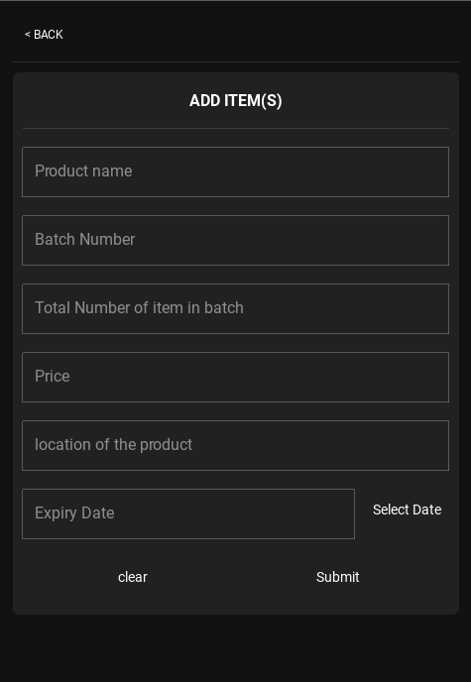

**CREATE QR-CODE**

E-KART streamlines product identification and information retrieval at the point of sale by offering a QR code generation feature within the store manager interface. This section explores the functionalities of the "Create QR Code" option.

**Automated QR Code Generation**

The "Create QR Code" feature empowers store managers to generate unique QR codes for existing stock items within the E-KART database. This process is entirely automated, eliminating manual tasks and potential human error.

**Leveraging Kivy Garden for QR Code Creation**

E-KART utilizes the Kivy Garden library, a popular Python framework extension, for seamless QR code generation. This integration allows the app to efficiently create QR codes that embed essential product information, including:

* **Product Name:** Clearly identifies the product associated with the QR code.
* **Unique Item ID:** A unique identifier differentiates individual items within the inventory, facilitating accurate stock tracking.
* **Batch Number:** Tracks specific batches of a product, aiding in product recalls or management if necessary.
* **Expiry Date:** Essential information for maintaining product safety and ensuring customer well-being.

**Concise Data Encoding (23 Bits)**

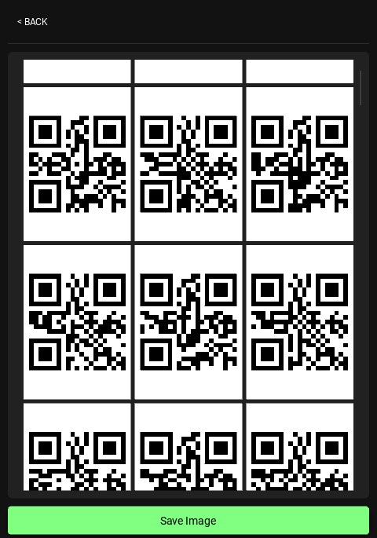E-KART optimizes QR code functionality by encoding only the most critical product data within the 23-bit limit.

**DELETE ITEM**

Maintaining accurate inventory levels is crucial for store success. E-KART equips store managers with the ability to efficiently remove outdated or unavailable products from their stock database, ensuring data accuracy and customer satisfaction.

* **Individual Item Deletion:** Store managers can select specific items for removal from the database. This might be necessary for products that have reached their expiry date, become damaged, or are otherwise unavailable for sale.
* **Bulk Deletion with "Select All":** For situations requiring the removal of multiple items, E-KART offers a convenient "Select All" button. This option allows store managers to efficiently select all items within the displayed list, facilitating faster deletion when necessary.

**Benefits of Efficient Stock Deletion:**

* 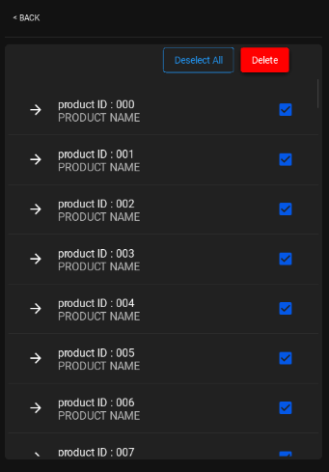**Accurate Inventory Records:** Removing outdated or unavailable items ensures accurate inventory data, preventing confusion and discrepancies during stock checks or customer purchases.
* **Reduced Sales of Expired Products:** Timely deletion of expired products safeguards customer health and brand reputation.
* **Improved Decision-Making:** Accurate inventory data empowers store managers to make informed decisions regarding restocking strategies and sales promotions.

**ADD OFFERS**

The "Add Offers" screen within the store manager interface provides a user-friendly platform for crafting strategic promotions. This section delves into the functionalities offered:

* **Offer Application:** Store managers can choose between two primary offer application methods:
* **Entire Store Offer (using "*"):** By utilizing the asterisk symbol ("*"), managers can create offers applicable to all products within the store. This is ideal for store-wide sales or clearance events.
* **Product-Specific Offer:** For targeted promotions, managers can specify a particular product name (as registered during stock addition) to apply the offer exclusively to that item. This allows for promoting specific products or clearing out excess stock.
* **Offer Code:** E-KART facilitates offer access through the use of unique offer codes. Managers can create custom alphanumeric codes that customers can enter at checkout to redeem the associated discount or promotion.
* **Inventory Check:** Before finalizing a product-specific offer, the system performs a real-time inventory check. If the chosen product is out of stock, a prominent toast message notifies the manager, and the product selection field is cleared to prevent applying discounts to unavailable items.

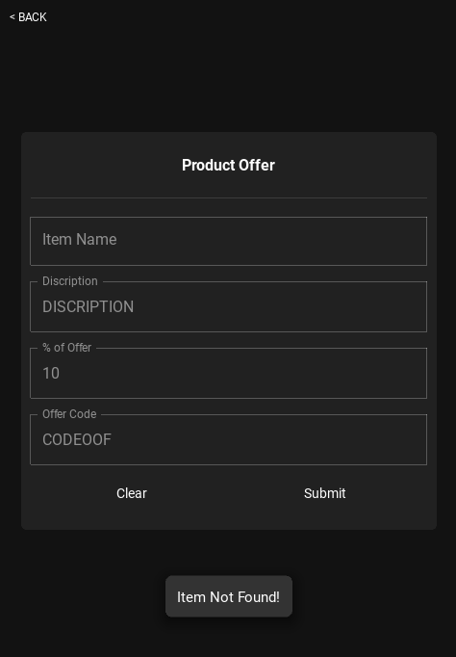

**VIEW STOCK**

Informed decision-making is crucial for store success. E-KART equips store managers with a comprehensive "View Stock" functionality, providing real-time insights into their inventory levels. This section explores how this feature empowers proactive inventory management.

**Real-Time Stock Overview**

The "View Stock" screen serves as a central hub for monitoring current inventory status within the store. This user-friendly interface presents a continuously updated list of all stocked products, providing vital details for each item:

* **Product Name:** Clearly identifies the product within the inventory.
* **Total Stock Left:** An accurate representation of the remaining quantity for each product, crucial for informed restocking decisions.
* **Batch Number:** Tracks specific batches of a product, aiding in product recalls or management if necessary.
* **Location (Label for Rack):** Provides a reference to the physical location of the product within the store, facilitating efficient retrieval during sales or stock checks.
* **Price:** Displays the current selling price of the product.

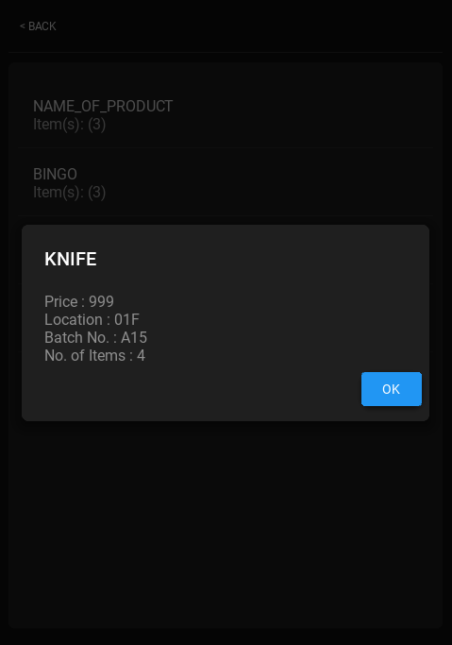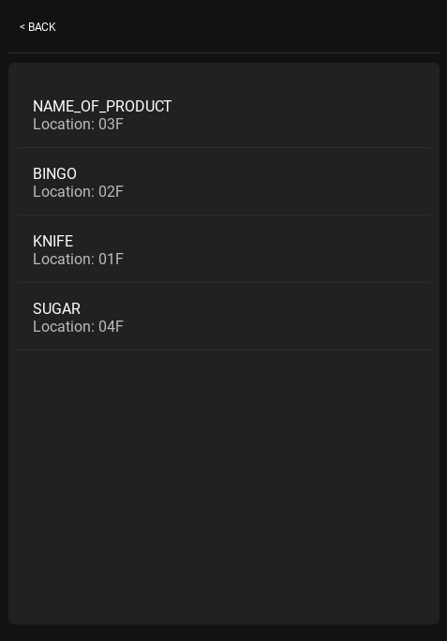

**ORDER STOCK**

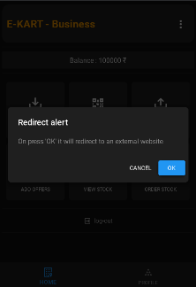The "Order Stock" function streamlines the restocking process by integrating with a curated list of pre-approved wholesale vendor websites. This eliminates the need for manual vendor searches or complex purchase orders. Here's a breakdown of the online ordering process:

* **Pre-Selected Vendor Websites:** E-KART curates a list of reputable wholesale vendors offering a wide range of products at competitive prices. This simplifies vendor selection for store managers.
* **Direct Website Access:** By clicking on a chosen vendor's website within the E-KART app, store managers are seamlessly redirected to the vendor's online ordering platform. This eliminates the need for manual website navigation or logins.

## PROFILE

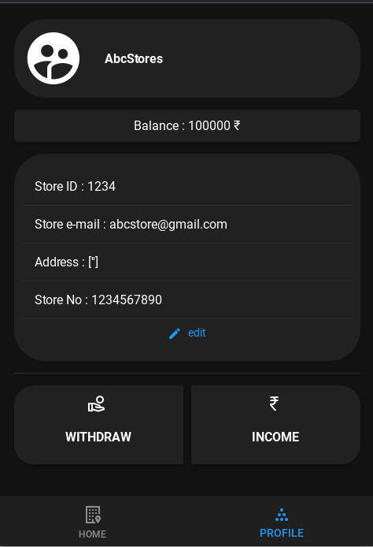profile screen readily available information streamlines reference and ensures data accuracy within the E-KART ecosystem. Here's a breakdown of the typical profile data points:

* **Store ID:** A unique identifier for the store within the E-KART network.
* **Store Name:** The official name of the store as displayed to customers.
* **Store Contact Information:** Contact details such as phone number or email address, allowing for communication between the store and E-KART support or external parties.
* **Store Address:** The physical location of the store, potentially used for various purposes like targeted promotions or deliveries.

# CUSTOMER

The E-KART customer home screen serves as a Launchpad for a seamless shopping journey. Here's a breakdown of the core features:

* **Find Nearby Stores:** This function empowers customers to locate E-KART stores within their vicinity. This aids in identifying the closest store for product availability checks or urgent purchases.
* **Scan & Pay:** For a quick and efficient checkout experience, E-KART offers a "Scan & Pay" feature. This functionality integrates two key elements:
  + **QR Code Scanner:** Customers can utilize their smartphone camera to scan product QR codes within the store. This retrieves product information and streamlines the checkout process.
  + **Order Summary & Payment:** A dedicated table displays scanned items, allowing customers to review their selections before proceeding to secure payment through the integrated payment gateway.
* 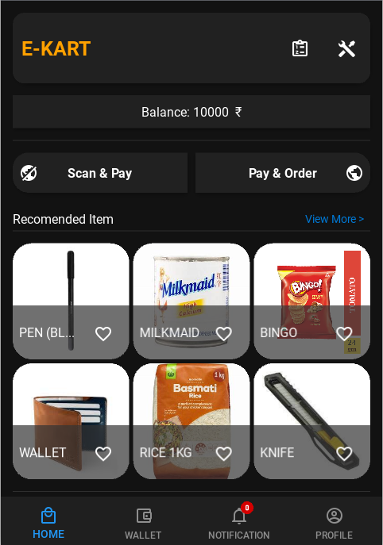**Order Online:** The home screen provides a convenient option for customers who prefer online shopping. Clicking the "Order Online" button redirects them to a trusted external website, potentially an E-KART partner or marketplace platform.
* **recommendations:** While the current implementation shuffles a random list of products upon entering the home screen.

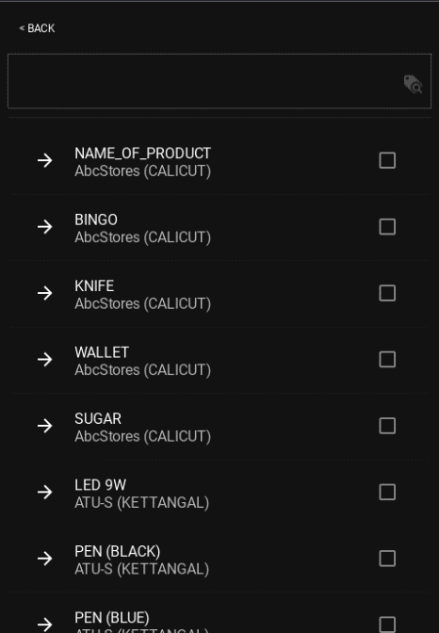**LIST PRODUCTS OF STORES**

* **Locate Nearby Stores:** The app leverages location services to identify E-KART stores within the customer's vicinity.
* **Browse Available Products:** For each nearby store, the app displays a list of currently stocked products. This information might be presented in order of proximity, with the nearest store's product listings appearing first.

**SCAN AND PAY**

The "Scan & Pay" feature eliminates the need for traditional queuing and checkout procedures. Here's a breakdown of the key functionalities:

* **Integrated QR Code Scanner:** The E-KART app seamlessly integrates a QR code scanner. Customers simply use their smartphone camera to scan the unique QR code affixed to each product within the store.
* **Smart Store ID Verification:** The initial product scan intelligently captures the store ID. Subsequent product scans verify if the store ID matches. Any mismatch triggers a warning pop-up, alerting the customer to a potential scanning error or product from a different store. This ensures accurate product identification and billing.
* **Real-Time Data Retrieval:** Upon successful scanning, the app retrieves product information from the E-KART database in real-time. This includes details like product name, price, and potentially additional specifications.
* **Confirmation Screen:** A dedicated confirmation screen displays the scanned product details, allowing customers to review their selection before proceeding to payment.
* **Secure Payment Gateway:** E-KART integrates with a secure payment gateway, enabling customers to conveniently pay for their purchases directly through the app using various payment methods.

**Additional Features:**

* **Offer Code Integration:** The "Scan & Pay" screen might allow customers to input offer codes obtained from the specific store, potentially leading to discounts or promotions.
* **Reward Points:** E-KART can explore implementing a loyalty program where customers earn reward points for using the app to scan and pay, further incentivizing its use.

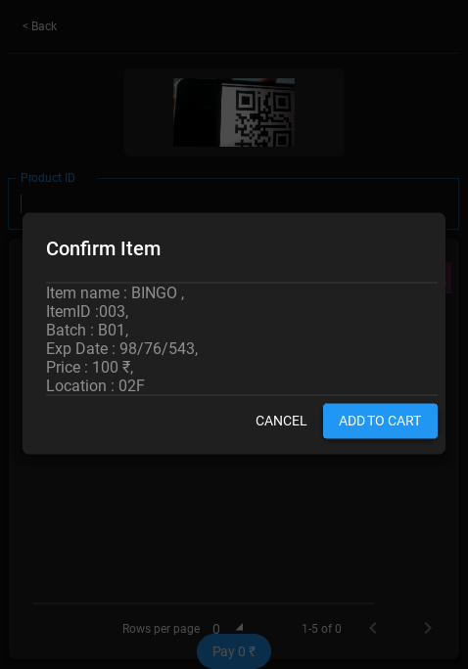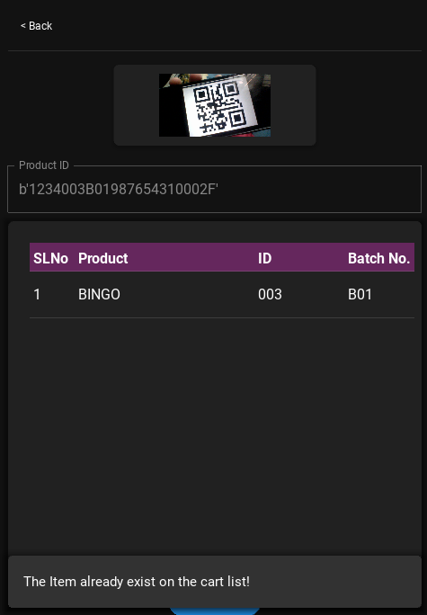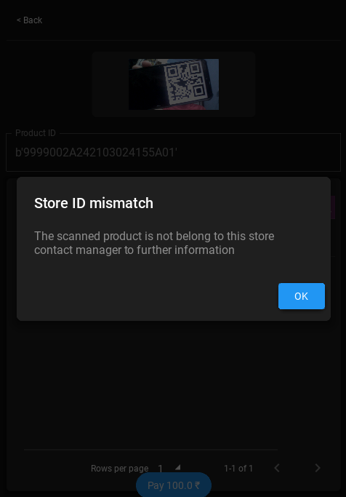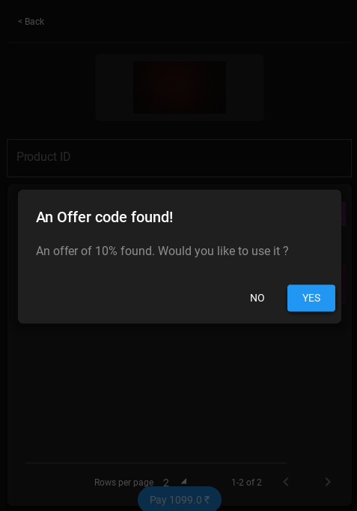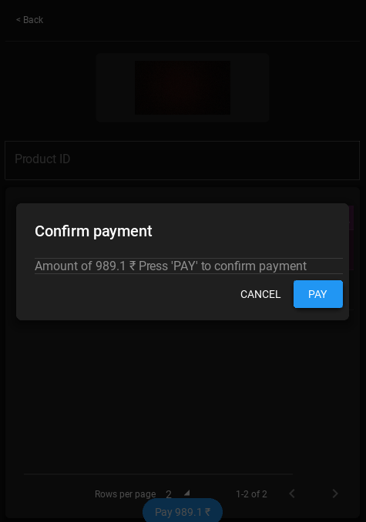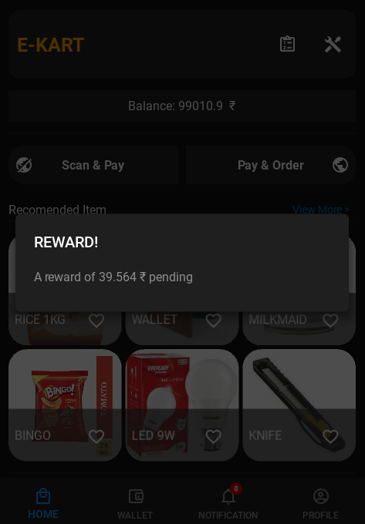

## WALLET

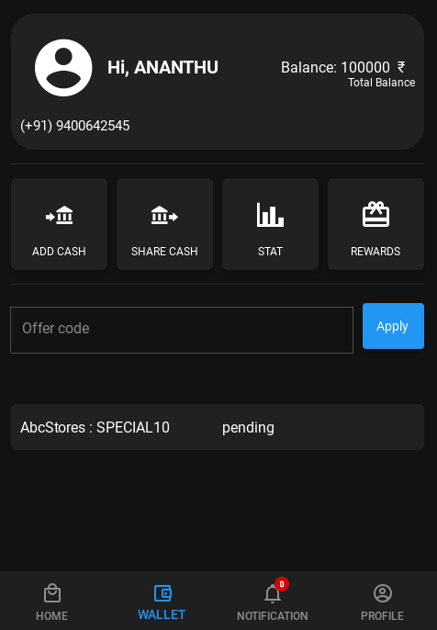The "Wallet" screen serves as a central hub for managing customer funds within the E-KART ecosystem. Here's an overview of its key features:

* **UPI Integration:** E-KART leverages the Unified Payment Interface (UPI), a robust and secure digital payment system widely used in India. This integration allows customers to seamlessly recharge their E-KART wallet directly from their linked bank accounts using their UPI credentials.
* **Secure Storage:** E-KART prioritizes user security by implementing secure hardware storage mechanisms to safeguard wallet balances. Customers can be confident that their in-app funds are protected.
* **Streamlined In-App Payments:** The E-KART wallet serves as the primary payment method for various functionalities within the app. This includes purchases made through "Scan & Pay" or potential future features like online ordering.

**RECHARGE WALLET**

The E-KART Wallet serves as the primary payment method for various functionalities within the app. This includes purchases made through "Scan & Pay" or potential future features like online ordering.

**Secure and Efficient Reloading:**

* **UPI Integration:** E-KART leverages the Unified Payment Interface (UPI), a robust and secure digital payment system widely used in India. This integration allows customers to effortlessly recharge their E-KART Wallet directly from their linked bank accounts using their UPI credentials.
* **Secure Hardware Storage:** E-KART prioritizes user security by implementing secure hardware storage mechanisms to safeguard wallet balances. Customers can be confident that their in-app funds are protected.

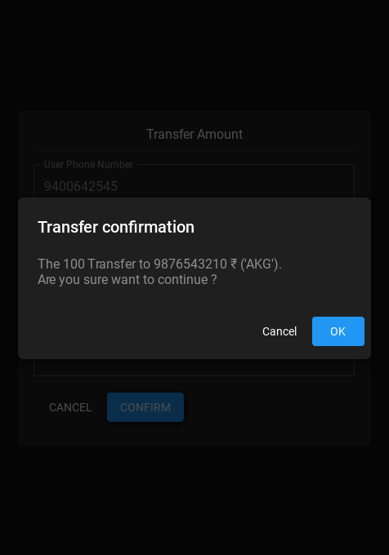**SHARE WALLET CASH**

Some time we need to share some cash to our friends or relative for their need so we can transfer cash from out account to their account by just regularly inputting the current user’s number, receiver’s number, amount, account password.

This fetch data from database to verify each and every input real time so the accident transfer and wrong number are avoiding.

Before transferring the fetched data shows the receiver name and the amount transfer, so user can confirm multiple time.

**REWARDS**

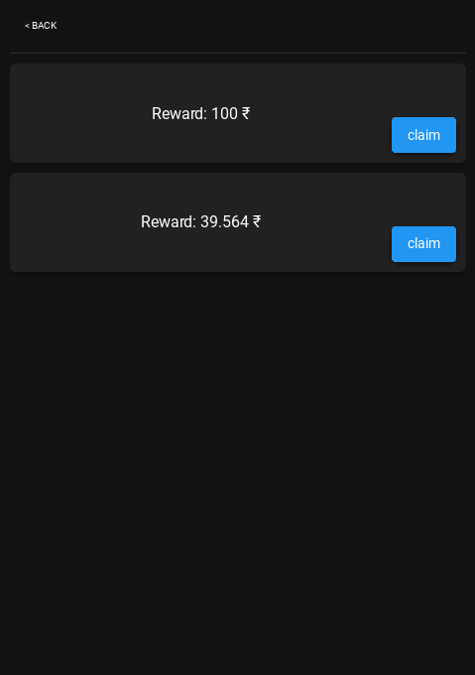E-KART acknowledges the value of customer loyalty. Here's how the E-KART Wallet rewards users for their in-store purchases:

* **Transaction-Based Rewards:** A specific percentage of some transaction amount paid through the E-KART Wallet is credited back to the user's account as reward points or cashback.
* **Reward Accumulation:** These reward points or cashback accumulate over time, providing users with an incentive to continue using the E-KART Wallet.

**Claiming and Utilizing Rewards:**

* **Dedicated Rewards Screen:** The E-KART app features a user-friendly "Rewards" screen that clearly displays the accumulated reward points or cashback.
* **Seamless Claiming Process:** A simple button or action within the "Rewards" screen allows users to effortlessly claim their accumulated rewards.
* **Enhanced Wallet Balance:** Once claimed, the rewards are added to the user's E-KART Wallet balance, increasing their purchasing power for future transactions.

**OFFER CODE**

E-KART recognizes the value of promotions and discounts. The E-KART Wallet integrates a seamless offer code redemption system:

* **Store-Generated Offer Codes:** Store managers can create targeted offer codes to promote specific products, incentivize purchases, or attract new customers.
* **User Input and Verification:** The "Wallet" screen includes a designated text field where users can input the offer code obtained from a store or E-KART marketing materials.
* **Real-Time Code Validation:** Upon clicking the "Apply" button, the system performs real-time verification against the E-KART database. This ensures the code is valid, active, and associated with a specific store.

## NOTIFICATION

E-KART notifications deliver important information directly to your smartphone, ensuring you never miss out on exciting opportunities. Here's a breakdown of the types of notifications you might receive:

* **Promotional Offers:** Receive alerts about ongoing sales, discount coupons, and special deals offered by stores within your vicinity or based on your shopping preferences.
* **Unclaimed Reward Reminders:** E-KART reminds you about any loyalty program rewards you've accumulated but haven't claimed yet, ensuring you maximize the benefits of your E-KART Wallet.
* 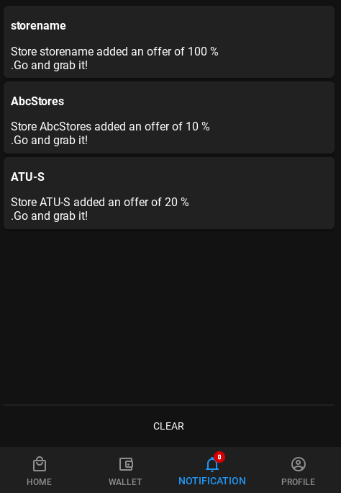**New Product Announcements:** Stay informed about exciting new product arrivals at your favourite E-KART stores.

## PROFILE

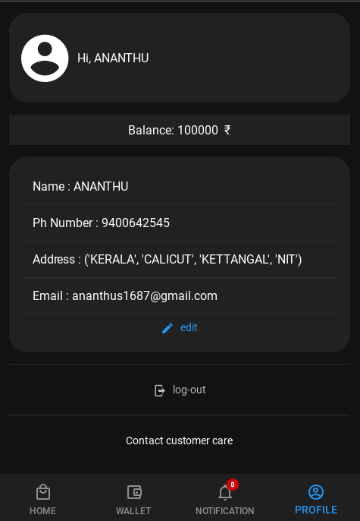The "Profile" screen serves as a central hub for managing your E-KART account information. Here's an overview of the key details you can access and update:

* **Personal Information:** View and edit your basic information, including your name, phone number, and email address.
* **Delivery Address:** Manage your saved delivery addresses for a more streamlined checkout process when placing online orders on futures.
* **Wallet Balance:** The profile screen conveniently displays your current E-KART Wallet balance, keeping you informed about your available funds for in-store purchases.

**CUTOMER CARE**

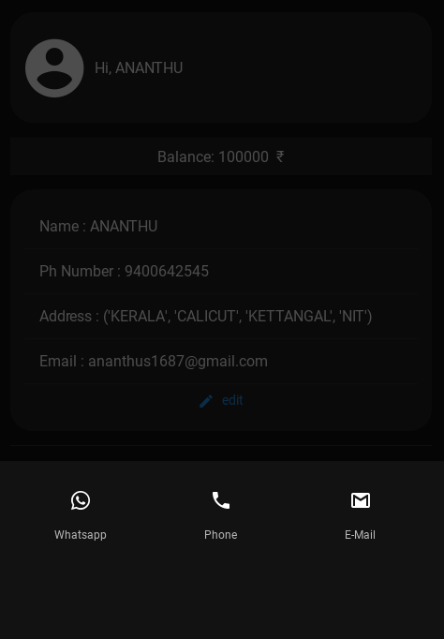The "Customer Care" section provides users with multiple convenient contact methods to reach E-KART's support team:

* **Toll-Free Number:** A dedicated toll-free number allows users to connect with a customer service representative over the phone for any inquiries or concerns.
* **Email Support:** Users can choose to submit their questions or request assistance via email for non-urgent matters. E-KART's support team will respond promptly through email.
* **WhatsApp Support:** Considering the widespread use of WhatsApp in India, E-KART could explore offering customer support through a dedicated WhatsApp number for added convenience.

# APPLICATIONS

## Customer Interface:

**Intuitive Shopping Experience:** E-KART provides customers with a seamless browsing and purchasing journey, featuring intuitive navigation, personalized recommendations, and streamlined checkout processes.

**Secure Payment Gateway:** Leveraging robust encryption protocols, E-KART ensures the security of financial transactions, safeguarding sensitive information and instilling trust among users.

**Digital Wallet Integration:** Customers can manage their finances effortlessly with E-KART's in-built digital wallet, enabling quick and secure transactions without the need for external payment methods.

**Responsive Customer Support:** With dedicated customer support channels, E-KART prioritizes user satisfaction by addressing queries, concerns, and feedback in a timely and responsive manner.

## Business Management Interface:

**Inventory Management:** E-KART equips businesses with robust inventory management tools, allowing for real-time monitoring of stock levels, automated reordering, and seamless integration with supply chain partners.

**Sales Analytics and Reporting:** Leveraging advanced analytics, E-KART provides businesses with actionable insights into sales performance, customer behaviour enabling data-driven decision-making and strategic planning.

**Marketing and Promotions:** E-KART facilitates targeted marketing campaigns and promotions, enabling businesses to engage with customers effectively, drive sales, and build brand loyalty.

**Vendor and Partner Management:** Businesses can efficiently manage vendor relationships and partnerships through E-KART's vendor portal, streamlining communication, transactions, and collaboration.

**Scalability and Customization:** With its modular architecture and customizable features, E-KART offers scalability and flexibility to adapt to the evolving needs and growth trajectories of businesses of all sizes.

# ADVANTAGES

## Enhanced Customer Experience:

* **Faster Checkouts and Reduced Wait Times:** The "Scan & Pay" feature eliminates traditional queuing and checkout processes. Customers can scan product QR-code with their smartphones and securely pay within the app, significantly reducing wait times and streamlining the shopping experience.
* **Convenience and Security:** The E-KART Wallet eliminates the need to carry cash or multiple debit/credit cards. Secure integration with UPI (Unified Payment Interface) ensures secure in-app transactions, fostering peace of mind for customers.

## Benefits for Partnered Stores:

* **Increased Efficiency and Reduced Costs:** "Scan & Pay" reduces checkout congestion, potentially allowing stores to operate with fewer cashiers during off-peak hours. This can optimize staffing needs and lead to cost savings for stores.
* **Improved Customer Engagement and Loyalty:** The E-KART app fosters customer loyalty through features like in-app rewards and personalized recommendations. This can encourage repeat business for stores and strengthen customer relationships.
* **Valuable Customer Insights:** E-KART can share anonymized customer behaviour data with partnered stores. This data can empower stores to optimize product placement, understand customer preferences, and tailor promotions for better sales results.

## Additional Advantages:

* **Potential for Integration with Loyalty Programs:** E-KART could integrate with existing loyalty programs of partnered stores. This would allow customers to seamlessly manage and redeem rewards points through the E-KART Wallet, enhancing the overall value proposition.

## Economic Benefits:

* **Cashless Transactions:** By promoting cashless transactions through UPI integration, E-KART can contribute to the Indian government's initiative towards a digital economy. This can lead to increased transparency, reduced risk of fraud, and improved financial inclusion.

# DISADVANTAGES

## Technical Challenges:

* **Dependence on Internet Connectivity:** The application requires a stable internet connection to function effectively. This could be a limitation in areas with poor internet connectivity, potentially hindering user adoption and hindering the app's reach in rural areas.
* **Technical Concern: Mobile Camera Functionality:** The "Scan & Pay" feature relies heavily on the user's smartphone camera to scan QR codes accurately. Malfunctioning cameras or low-quality smartphone cameras could disrupt the shopping experience and lead to frustration for users.
* **QR-Code Scanning Issues:** There could be potential issues with scanning QR codes, especially if they are not printed clearly (due to wear and tear, damage, or poor printing quality) or if the user's device camera is not of good quality. This can lead to failed scans and disrupt the checkout process.

## User Adoption and Behavioral Considerations:

* **Learning Curve:** While E-KART is designed to be user-friendly, there may still be a learning curve for users who are not familiar with such applications. This could be a barrier for older demographics or those less comfortable with technology, potentially hindering wider user adoption.

## Security Concerns:

* **Security Risks:** Despite built-in security measures, mobile payment applications are inherently susceptible to cybersecurity threats such as hacking, phishing, and data breaches. E-KART must prioritize robust security measures, user education on safe practices, and continuous monitoring to mitigate these risks and maintain user trust.

## Additional Considerations:

* **Technical Maintenance:** Like any software application, the E-KART mobile app requires ongoing maintenance, updates, and bug fixes to address user issues, enhance performance, and ensure compatibility with evolving technologies and industry standards. This requires investment in a dedicated development team and a commitment to continuous improvement.

# FUTURE SCOPE

* **Advanced Inventory Management**: The application could incorporate advanced inventory management features, such as predictive analysis for stock replenishment, sales forecasting, and integration with supply chain management.
* **Enhanced Payment Options**: While the application currently supports in-app payments, future versions could include support for various other payment methods like digital wallets, UPI (Unified Payments Interface), and cryptocurrency.
* **AI-Powered Recommendations**: The application could use machine learning algorithms to analyze user behavior and provide personalized product recommendations.
* **Security Enhancements**: As the application grows, it will be crucial to continually update and enhance security measures to protect user data and ensure secure transactions.
* **Rewards and Loyalty Programs:** Implement rewards and loyalty programs to incentivize customer loyalty, encourage repeat purchases, and foster long-term relationships with users.
* **Biometric Authentication:** Incorporate biometric authentication methods, such as fingerprint or facial recognition, to enhance security and user authentication during transactions, reducing reliance on traditional passwords.
* **Advanced Encryption Techniques:** Implement advanced encryption techniques and cybersecurity protocols to fortify the application against emerging threats and vulnerabilities, ensuring the safety of user data and financial information.
* **Integration with Third-Party Services:** Forge partnerships with third-party service providers, such as logistics companies and payment gateways, to facilitate seamless integration and expand the range of services offered through the application.
* **Internationalization:** Customize the application to support multiple languages, currencies, and cultural preferences, enabling localization and catering to diverse global markets.
* **Geographic Expansion:** Explore opportunities for geographic expansion into new regions and markets, adapting the application to meet the unique regulatory requirements and consumer preferences of each target market.

# CONCLUSION

In conclusion, E-KART represents a transformative force in the realm of e-commerce, offering a robust platform that combines cutting-edge technology with user-centric design to deliver unparalleled convenience, efficiency, and value to both businesses and consumers. As we reflect on the journey of E-KART, several key insights emerge, highlighting the platform's impact and potential for future growth and innovation.

E-KART's success lies in its ability to address the evolving needs and expectations of users in the dynamic e-commerce landscape. By leveraging Python's Kivy and KivyMD frameworks, E-KART delivers an intuitive and feature-rich platform that streamlines the online shopping experience, enhances security, and drives business success. Through its customer-centric interfaces, personalized recommendations, and responsive support, E-KART fosters customer satisfaction, loyalty, and trust, laying the foundation for sustainable growth and profitability.

Looking ahead, the future of E-KART is filled with promise and potential, as the platform continues to evolve and adapt to emerging trends and technologies. By embracing innovations such as AI-powered personalization, augmented reality shopping experiences, and block chain technology for enhanced security and transparency, E-KART can further elevate its capabilities and solidify its position as a leader in the e-commerce industry.

As we embark on this journey of innovation and growth, E-KART remains committed to its core values of integrity, excellence, and customer-centricity. By staying true to these principles and remaining agile and responsive to the evolving needs of businesses and consumers, E-KART is poised to shape the future of e-commerce, driving economic growth, fostering innovation, and empowering businesses and individuals to thrive in the digital economy.

# REFERENCE

1. Python Software Foundation. (2022). Python Documentation. Retrieved from https://docs.python.org/
2. Kivy Team. (2022). Kivy Documentation. Retrieved from https://kivy.org/doc/stable/
3. KivyMD Developers. (2022). KivyMD Documentation. Retrieved from https://kivymd.readthedocs.io/en/latest/
4. Smith, J. (2021). E-Commerce Trends: A Comprehensive Analysis. Business Publications Inc.
5. Johnson, A. (2020). "Mobile Payment Applications: A Comparative Study." Journal of E-Commerce Research, 15(2), 112-125.